**Data Upload – Human Resources analysis – Data**

1.

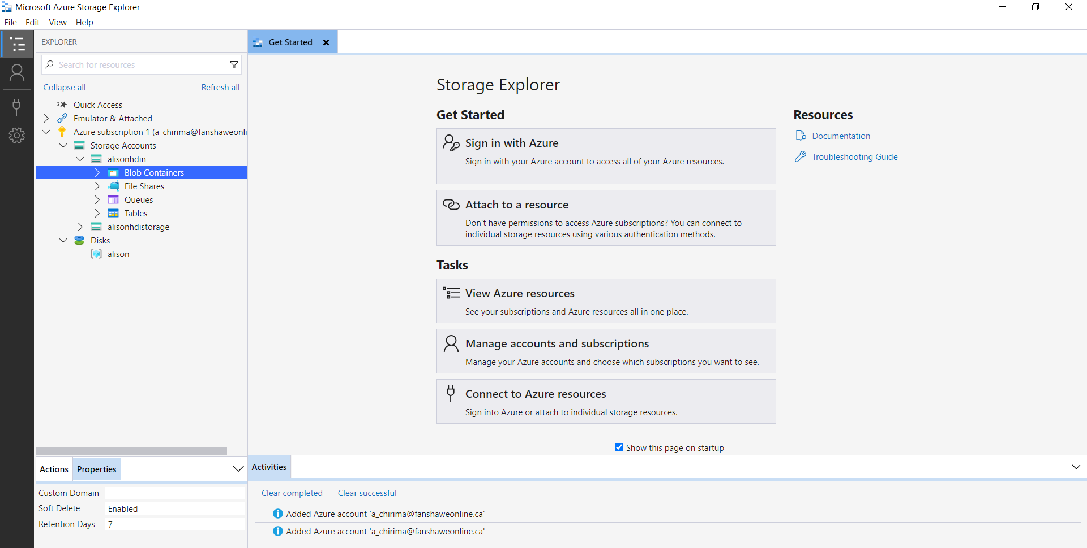

2.

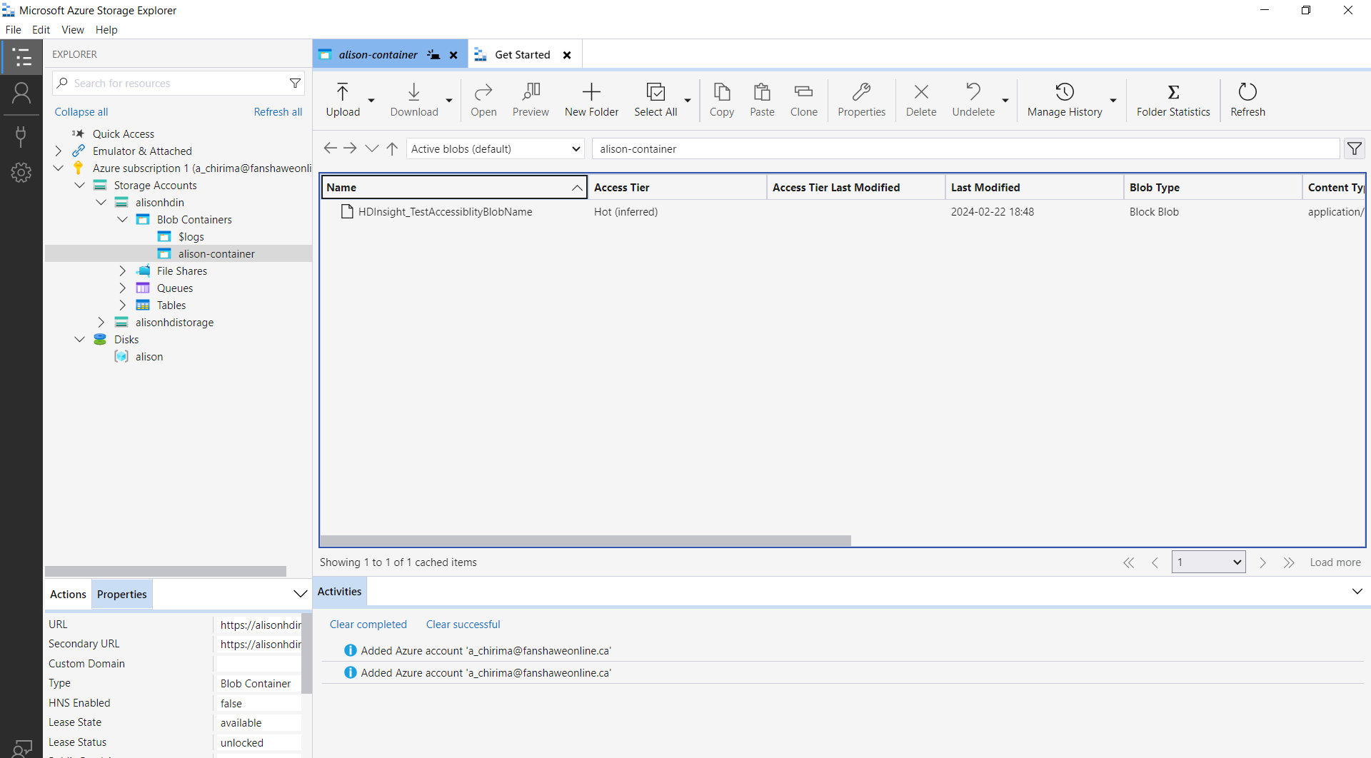

3.

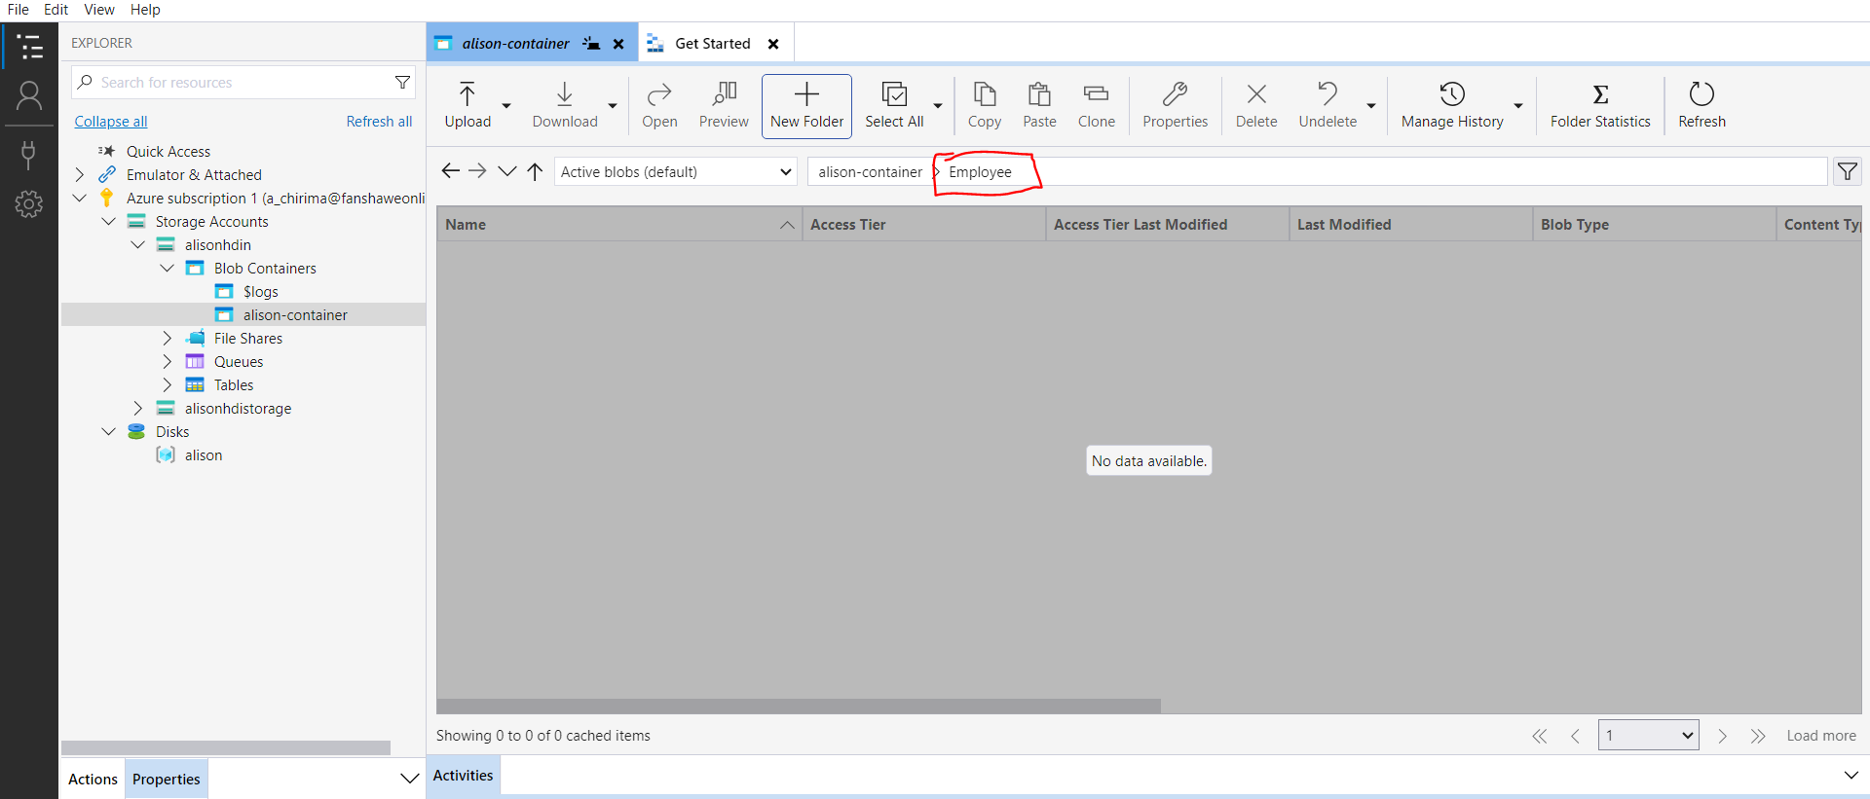

4.

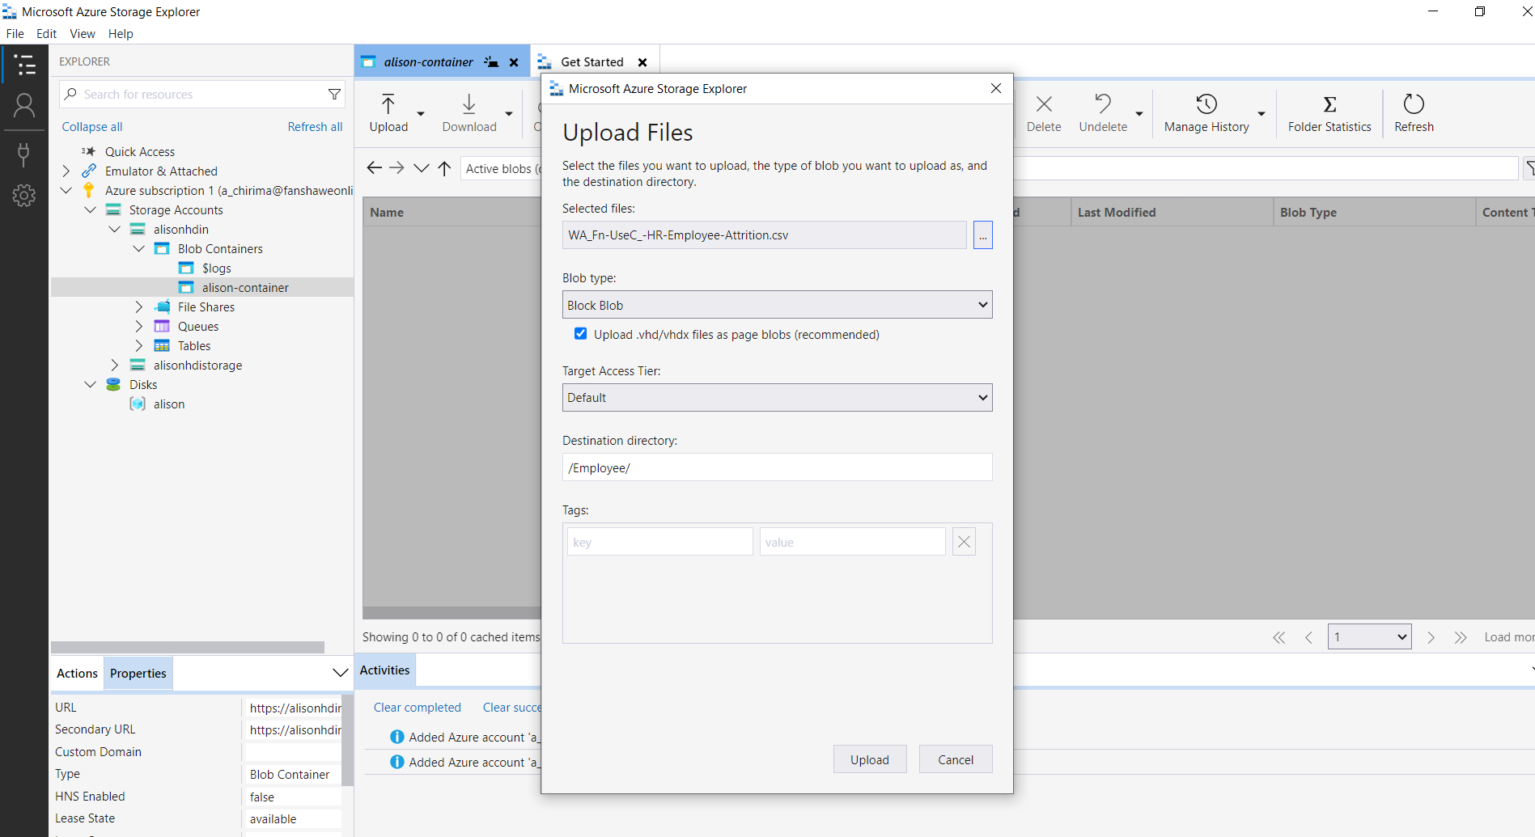5. 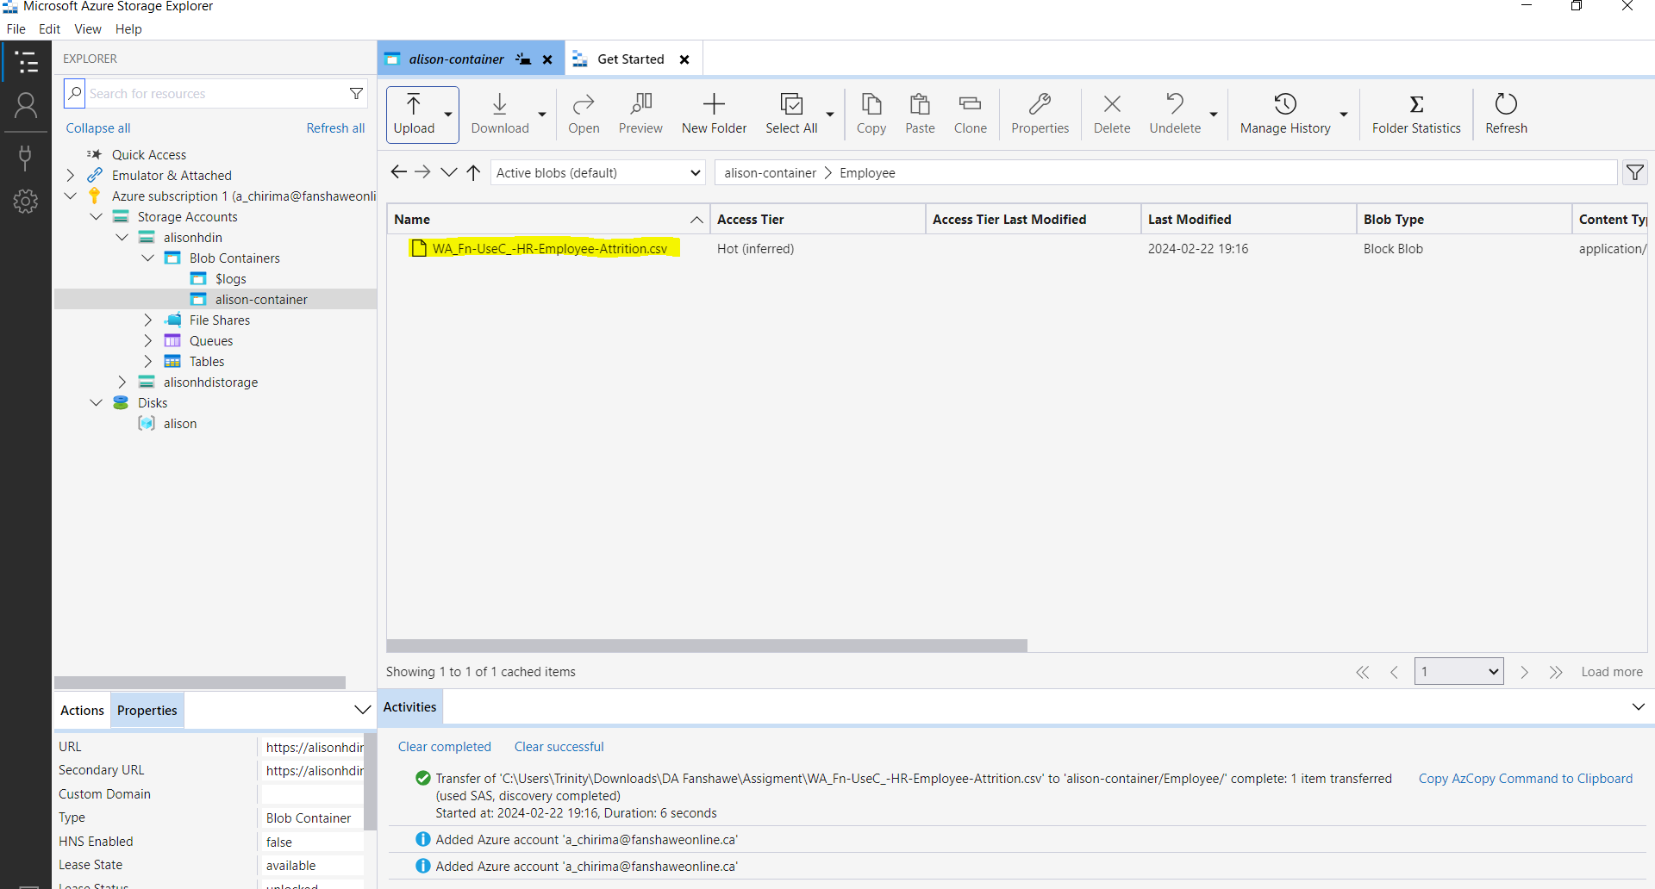

6.

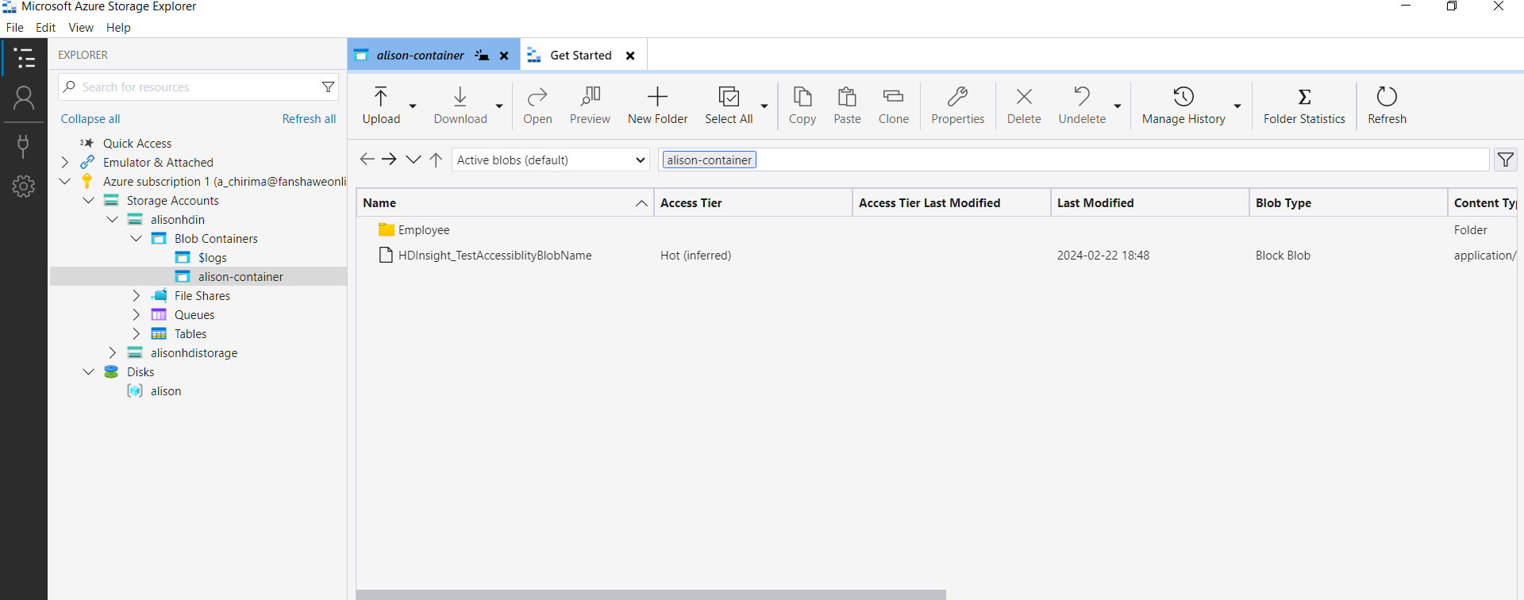

7.

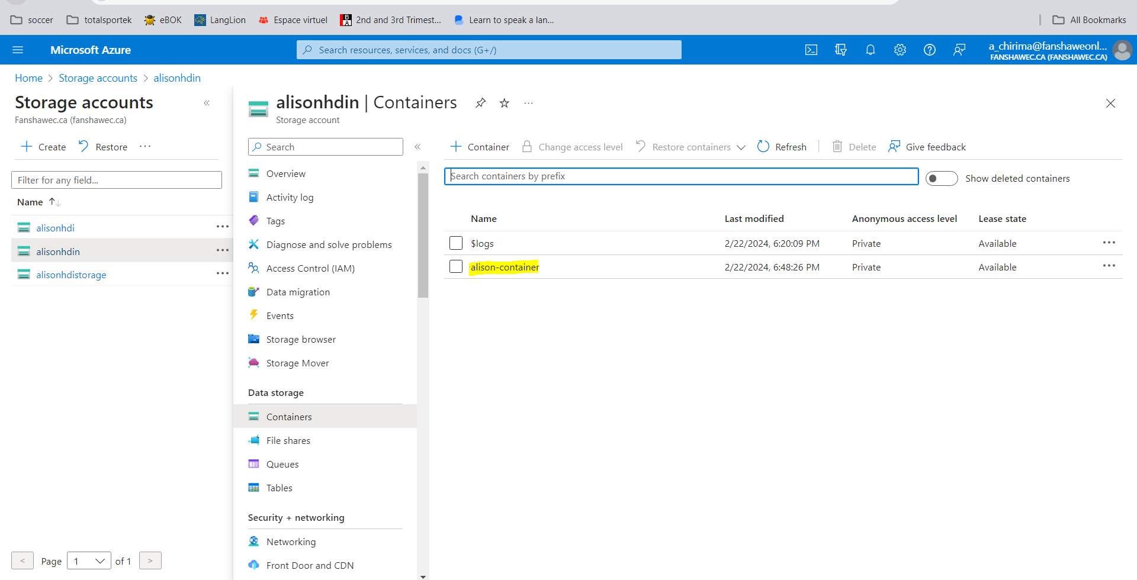

8.

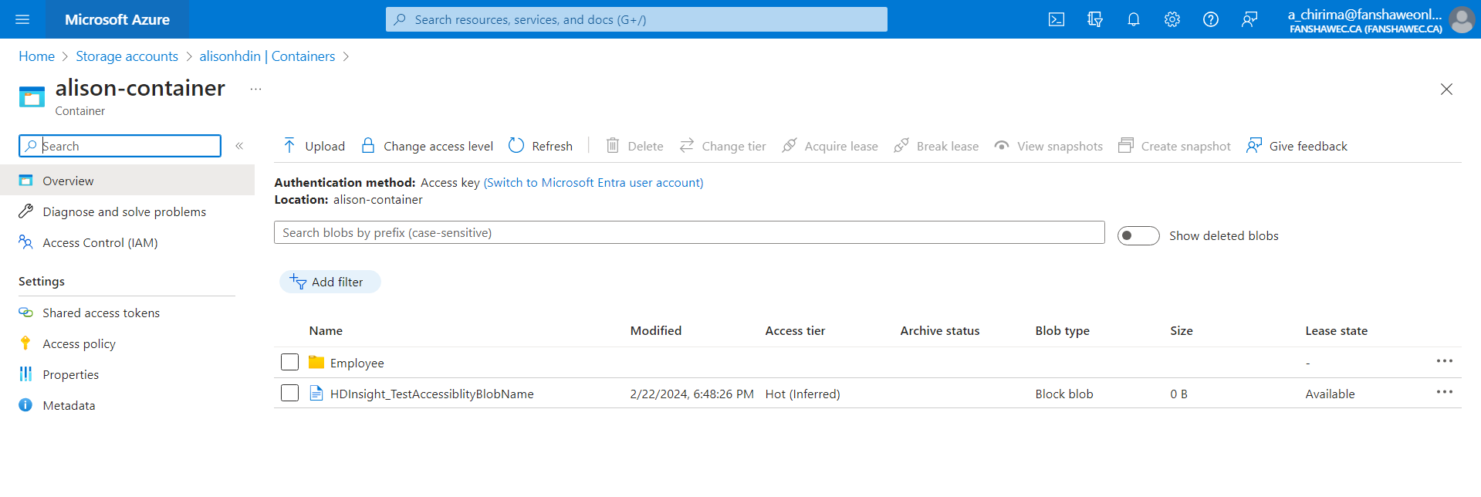

9.

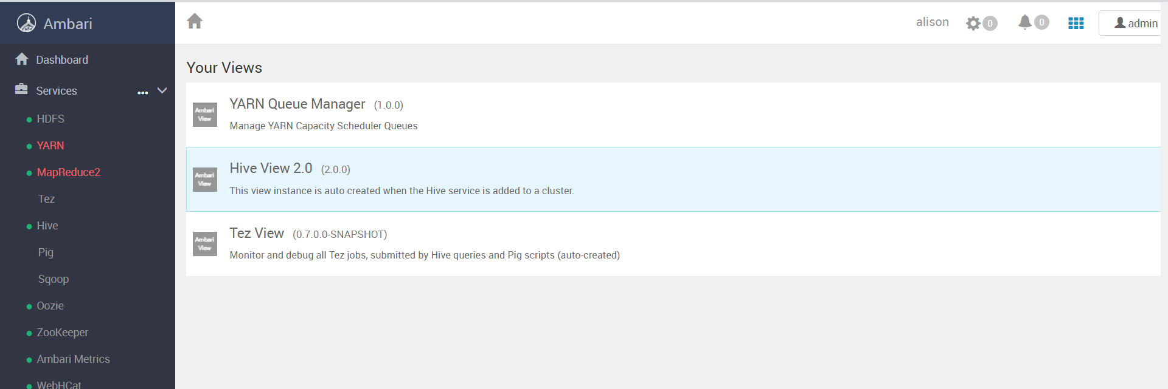

10.

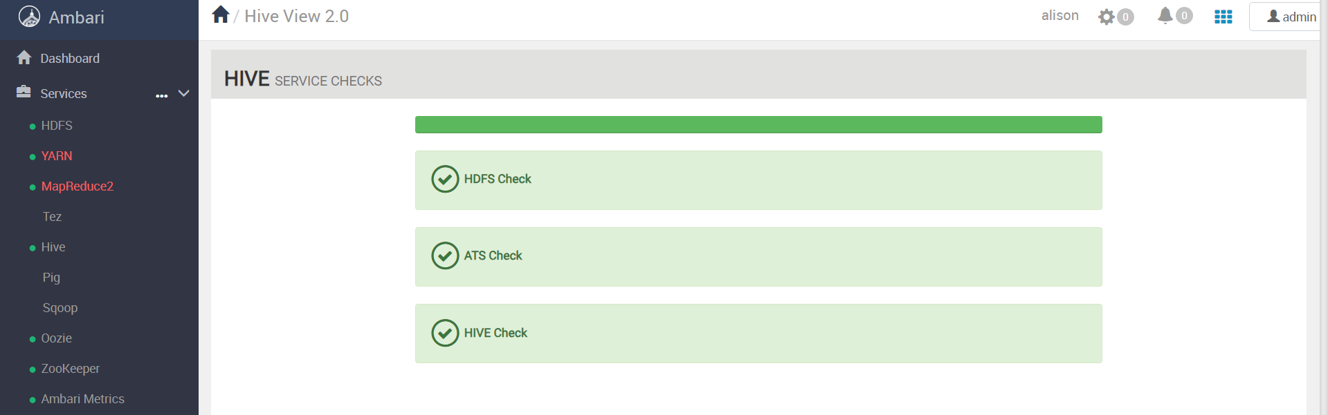

11.

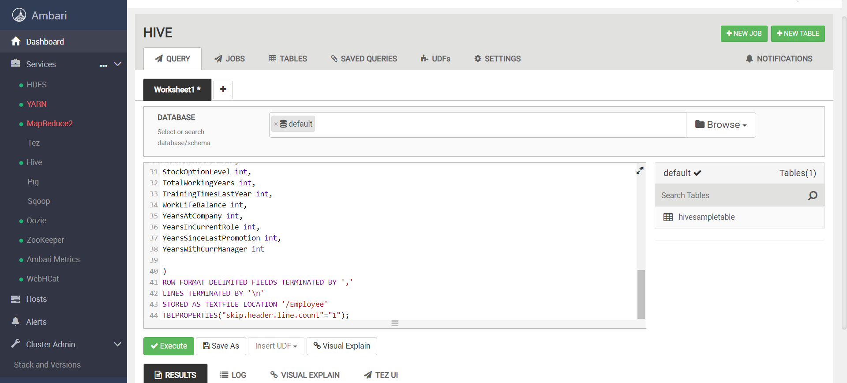

CREATE EXTERNAL TABLE Employee

(

Age int,

Attrition string,

BusinessTravel string,

DailyRate int,

Department string,

DistanceFromHome int,

Education int,

EducationField string,

EmployeeCount int,

EmployeeNumber int,

EnvironmentSatisfaction int,

Gender string,

HourlyRate int,

JobInvolvement int,

JobLevel int,

JobRole string,

JobSatisfaction int,

MaritalStatus string,

MonthlyIncome int,

MonthlyRate int,

NumCompaniesWorked int,

Over18 string,

OverTime string,

PercentSalaryHike int,

PerformanceRating int,

RelationshipSatisfaction int,

StandardHours int,

StockOptionLevel int,

TotalWorkingYears int,

TrainingTimesLastYear int,

WorkLifeBalance int,

YearsAtCompany int,

YearsInCurrentRole int,

YearsSinceLastPromotion int,

YearsWithCurrManager int

)

ROW FORMAT DELIMITED FIELDS TERMINATED BY ','

LINES TERMINATED BY '\n'

STORED AS TEXTFILE LOCATION '/Employee'

TBLPROPERTIES("skip.header.line.count"="1");

12.

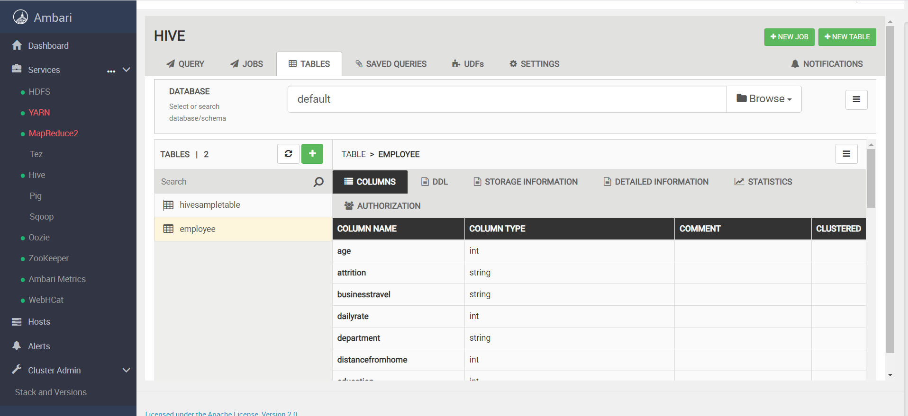

1. **Validating the schema if its correct using the “table view” tab.**

1.

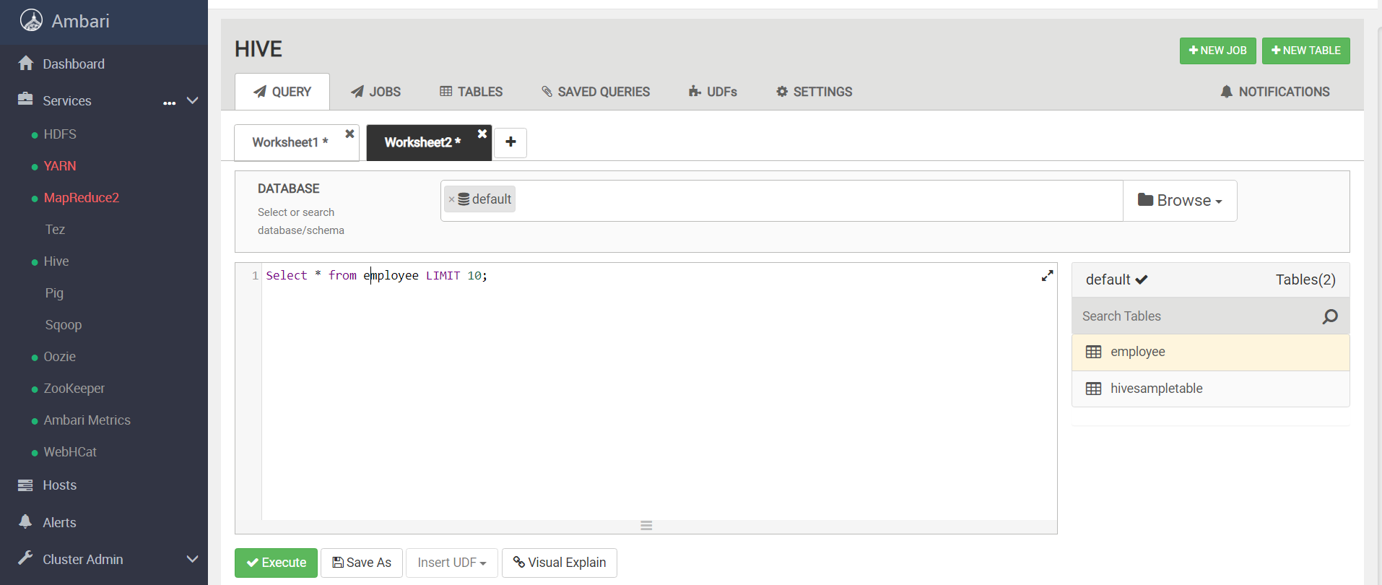

2.

~END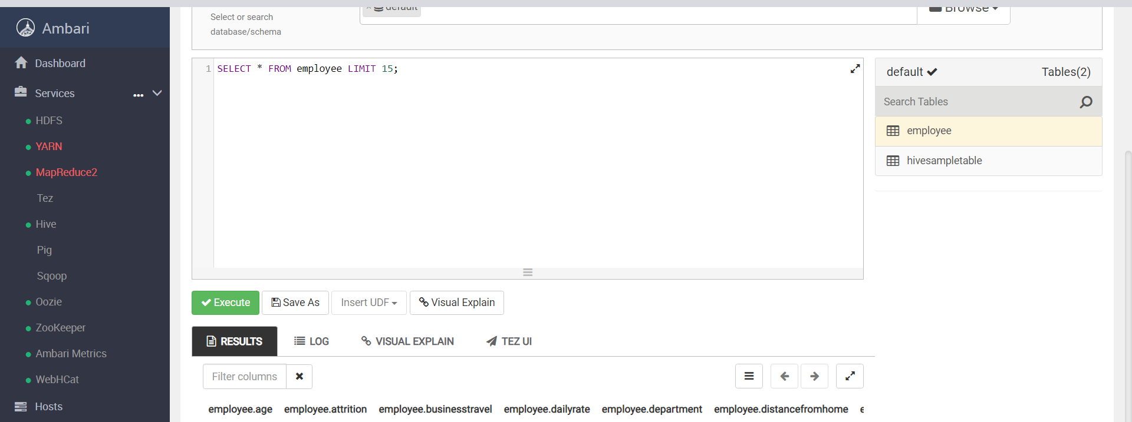

~END~